In section [2.2.1], it is shown that the electronic part of the anemometer is a mechanical device called the reed switch. As a standalone device, a reed switch does not create any electrical signals to be read, thus the use of a setup as simple as illustrated in Figure 1.

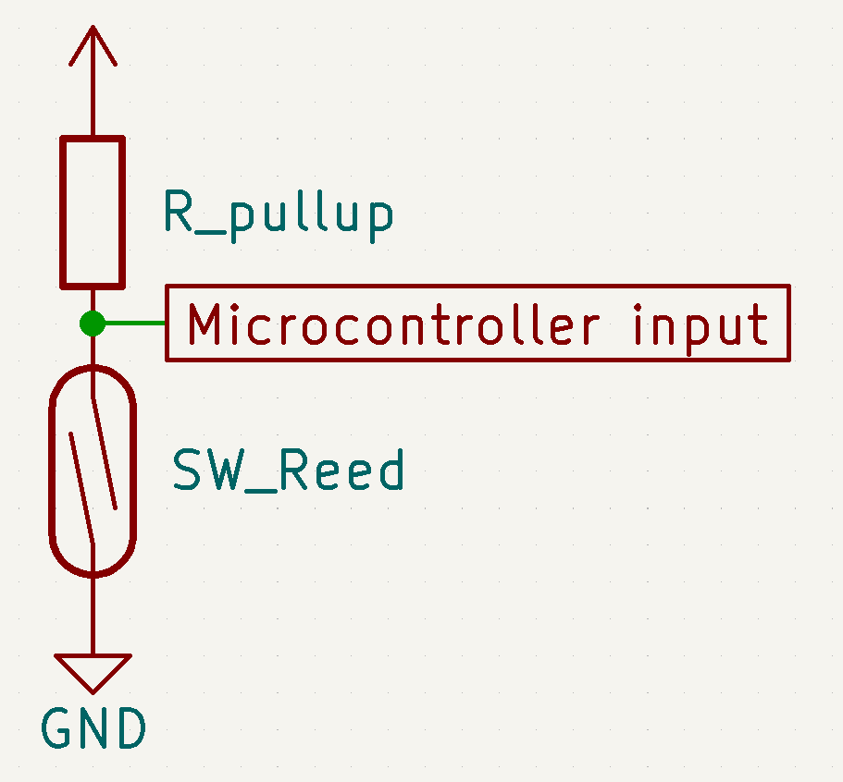

Figure 1. Basic setup for reading a mechanical switch

The circuitry in Figure 1 generates active-LOW outputs by the use of a pull-up resistor, which means the microcontroller normally reads logic 1 and detects a logic 0 when the switch closes. Active-HIGH outputs could be achieved by switching the positions of the reed switch (SW_Reed) and the resistor (R_pullup); however, since there are potentially errors due to interference while the microcontroller detects logic 1 in that setup, active-HIGH signals are undesirable in this project.

The pull-up resistor value could be chosen for either strong or weak pull-up purpose. A resistor with a high value creates a weak pull-up which results in lower power consumption, and vice versa [1]. If the input impedance on the microcontroller pin is unknown, it is safe to choose a strong pull-up resistor (i.e. 4.7kΩ). However, [2] specifies that a resistor from 30kΩ to 50kΩ could be used to achieve a weak pull-up for an STM32F103CBT6 microcontroller, so the value of 33kΩ is chosen in this project. As a result, the design would be more suitable as a battery-powered application.

[1] SparkFun, “Pull-up Resistors,” *SparkFun*. https://learn.sparkfun.com/tutorials/pull-up-resistors/all (accessed Jul. 26, 2023).

[2] STMicroelectronics, “STM32F103x8, STM32F103xB.” pp. 1–116, 2022.